ERLITE ERGO UNI

Erlite Ergo Uni is a three-layer firefighting suit developed based on the experience and needs of Czech professional firefighters. The suit combines the Austrian know-how of seamTEX, a leading manufacturer of firefighting garments, with the Czech manufacturing tradition of Holík.

It is built on the PREMIUM-N/NXT material system, whose performance is based on a carefully engineered combination of materials and a unique layer construction. The result is a balanced combination of protection, breathability, low weight and ergonomics.

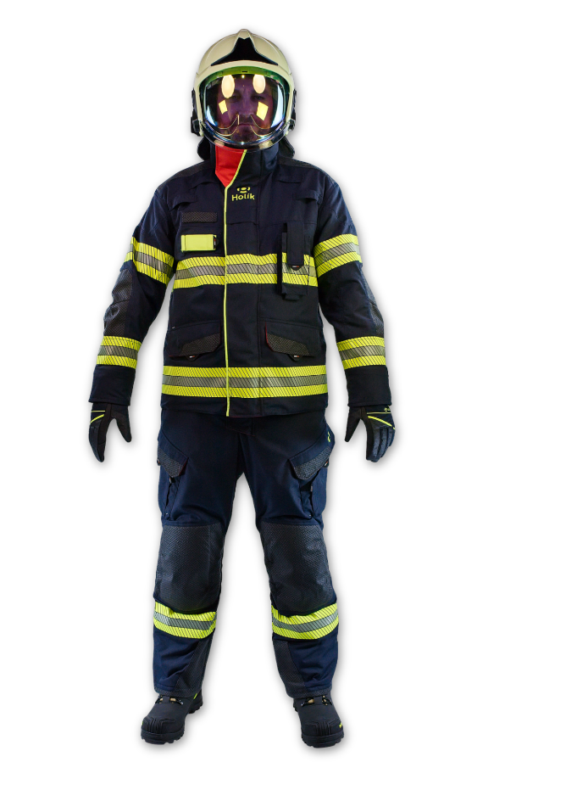

Color: Navy Blue
Outer material: Nomex® Outershell Tough
Sizes: XS–4XL (length options: N, K, KK, L, LL))
OUTSTANDING PROTECTION
thanks to Nomex® and Kevlar® aramid materials

HIGH BREATHABILITY
seamTEX® PTFE Fire Insert membrane for effective water vapour transmission and reduced heat stress

LOW WEIGHT
ultra-lightweight material construction with a total weight of up to 500 g/m²

ERGONOMICS
pre-shaped knees with foam padding for comfortable movement when kneeling

SeamTEX PREMIUM-N/NXT Material System Outershell Tough designed for demanding firefighting operations and extreme emergency response conditions.

- Material composition: 75% Nomex®, 23% Kevlar®, 2% antistatic fibre
- High mechanical resistance while maintaining low weight
- Hydrophobic treatment resistant to up to 30 washing cycles without re-impregnation

THERMAL INSULATION AND LINING
- Combination of aramid fleece and FR viscose with aramid fibres for thermal comfort and effective moisture management.

MEMBRANE
- Extremely lightweight PTFE membrane with a weight of 90 g/m² ensures high breathability with minimal weight.





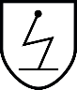


EN 1149-5
EN ISO 11612

EN ISO 343

STANDARDS:
ISO 13506-2
EN 469 Xf 2, Xr 2, Y 2, Z 2
EN 1149-5
EN 343 Class 4/4
EN ISO 11612 A1, B2, C1, F2

Arclin®, the Arclin logo, Kevlar®, Nomex®, Firepoint® and all trademarks and service marks denoted with ™, SM or ® are owned by Arclin and its affiliates unless otherwise noted. © 2026 Arclin. All rights reserved.
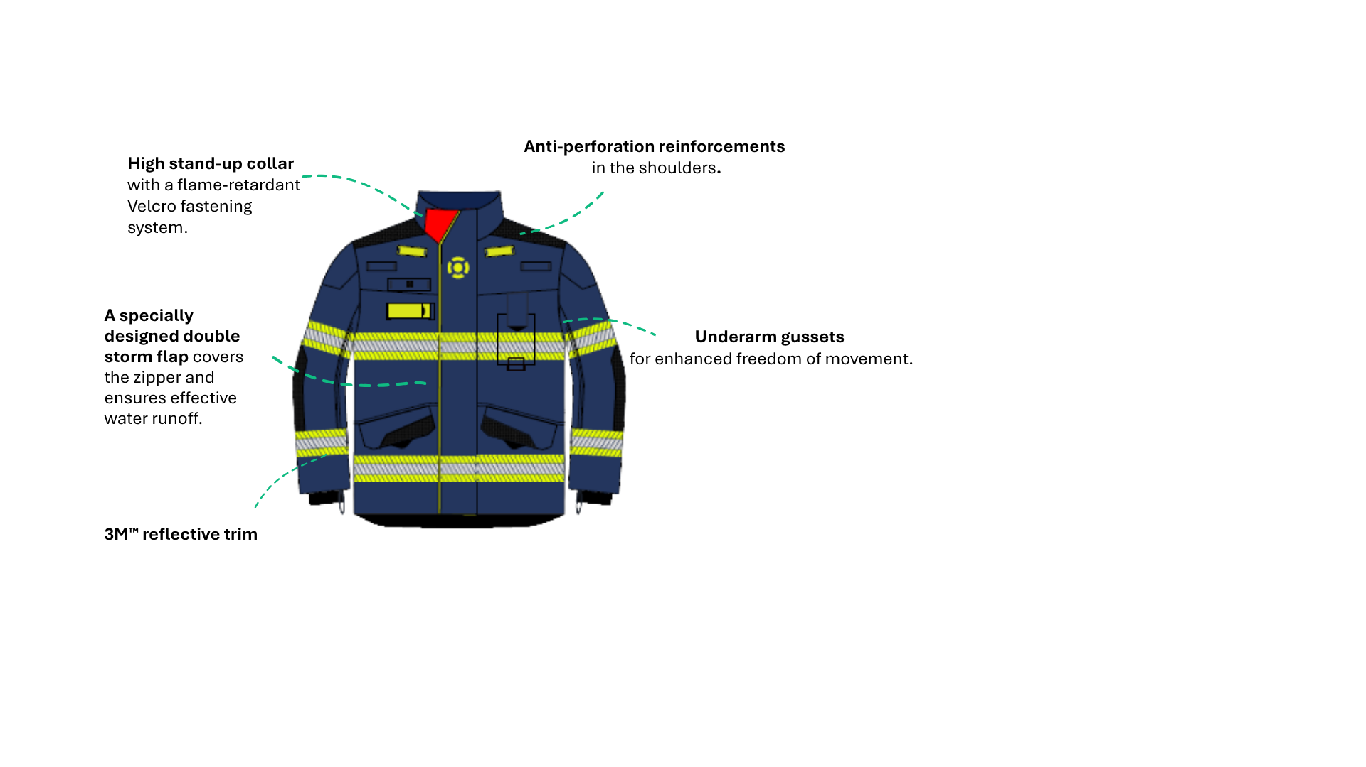
ERLITE ERGO UNI

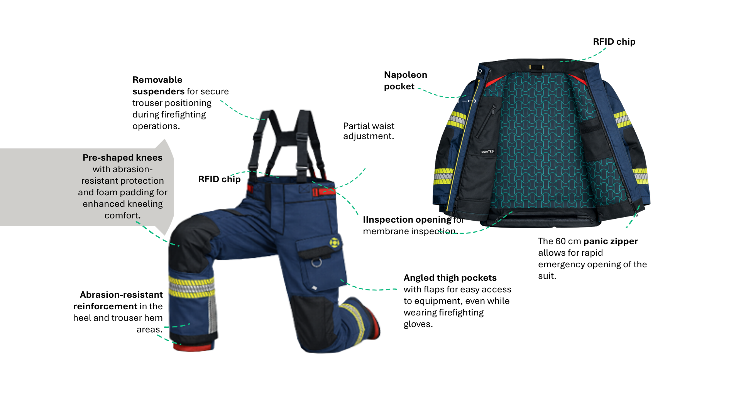

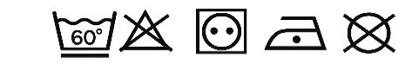
CARE AND WASHING:
Select a gentle 60 °C wash programme with pre-wash. Use detergent for coloured or delicate laundry. Do not use fabric softener, bleach or organic solvents. Spin at a maximum of 800 rpm and tumble dry gently at low temperature only.
For more about washing and maintenance, see the QR code or visit:
www.holik.com > Technologies > Care & Maintenance



1/2026
Holík International, s.r.o.
Za Dvorem 612, Štípa, 763 14 Zlín
Tel.: +420 577 125 500
E-mail: info@holik.com
Instagram: holik_international
Facebook: holikinternational
Web: www.holik.com
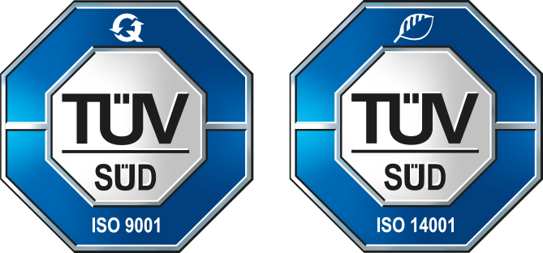
Holík GmbH
Lise-Meitner-Straße 1-13
D-42119 Wuppertal
Tel.: +49 (0) 202 786 6278
Mob.: +49 170 788 8432
E-mail: mail@holik-gmbh.de
Web: www.com



